OPERATION MANUAL of JAC CHARGERS
Caution
- Before using the battery charger - please read all instructions and cautionary markings.
- Use the battery charger in a well ventilated area - for indoor use only.
- To avoid the risk of injury, charge only lead-acid or gel cell type rechargeable batteries.
- Beware of correct polarity. (5) Slight heat on the exterior while charging.
(6) Avoid exposure to heat (7) Please remove the plug from AC power outlet after charging
Instruction of charging procedure
- Connect correct polarized clips to battery terminals.
- Connect to mains and switch on. Then charging starts - Red (2A) / Orange (3A-12A) LED light.
- At green light keep charging for a couple of hours for complete charging.
- When charging finished (Green LED), disconnect from mains and remove clips from battery.
(5)- Charging can continue in "Float stage" without harming the battery.
LED Indication
2A Charger RED : Charging GREEN : Full charged
3A~ 12A Charger LED1 : RED -> Power on LED2 : ORANGE -> Charging GREEN -» Full charged
FAN Control (3A~ 12A only )
1) Fan on fastspeed (Bulk/Absorption Charge) 2) Fan on slow speed (Float Charge)
Charging Curve

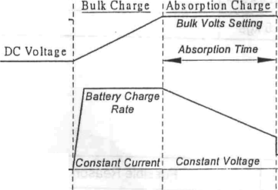
Float Charge
Charging Started '
AC Current
Float Volts Selling
3-Stage Battery Charger DC Voltage and AC current Charge Profile
Reduced Current and Voltage

Time

Case Picture: 2 Amp Charger 3 to 12 Amp Charger

